CARE TO SPEAK
SOCIAL MEDIA KIT

CARE TO SPEAK POSTS
Facebook | Twitter | Instagram
Have you heard of Care to Speak? It is a confidential and free service that provides mental health support to those working in healthcare and social services.  Care to Speak is a peer service meaning it is staffed by trained volunteers with experience in healthcare and social services. It is open Monday to Friday 9am-9pm.  #caretospeak  https://bit.ly/37NJwDF  or to link to the media release  Tag: @cmha_bc  @safecarebc  @governmentofbc  @cmhavernon | Have you heard of Care to Speak? It is a confidential and free service that provides mental health support to those working in healthcare and social services.  Care to Speak is a peer service meaning it is staffed by trained volunteers with experience in healthcare and social services. It is open Monday to Friday 9am-9pm.  #caretospeak  https://bit.ly/37NJwDF  or to link to the media release  Tag: @cmha_bc  @safecarebc  @governmentofbc  @cmhavernon | Have you heard of Care to Speak? It is a confidential and free service that provides mental health support to those working in healthcare and social services.  Care to Speak is a peer service meaning it is staffed by trained volunteers with experience in healthcare and social services. It is open Monday to Friday 9am-9pm.  #caretospeak  https://bit.ly/37NJwDF  or to link to the media release  Tag: @cmha_bc  @safecarebc  @governmentofbc  @cmhavernon  #caretospeak #careforecaregivers #safecarebc #cmhabc #cmha #help  #mentalhealth #socialservices #healthcareheroes #careproviders #healthcareworkers #anxiety #depression #socialwork #mentalhealthresources #mentalhealthsupport #mentalhealthhelp #frontlineworkers #peersupport
Working under acutely stressful circumstances for prolonged periods of time can really impact our mental health. But talking to someone who understands those challenges can help.  Healthcare and social service workers seeking person-to-person support can talk with a trained peer support volunteer via text or phone at 1-866-802-7337 (PEER) Monday-Friday 9am-9pm. #caretospeak  https://bit.ly/37NJwDF  or to link to the media release  Tag: @cmha_bc  @safecarebc  @governmentofbc  @cmhavernon  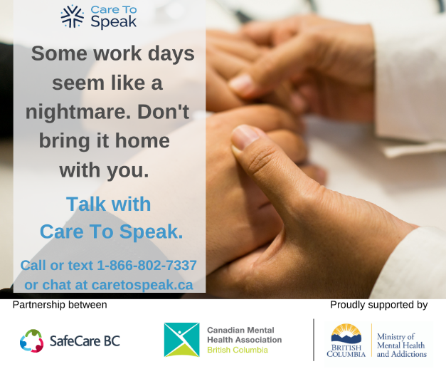 | Working under acutely stressful circumstances for prolonged periods of time can really impact our mental health. But talking to someone who understands those challenges can help.  Healthcare and social service workers seeking person-to-person support can talk with a trained peer support volunteer via text or phone at 1-866-802-7337 (PEER) Monday-Friday 9am-9pm. #caretospeak  https://bit.ly/37NJwDF  or to link to the media release  Tag: @cmha_bc  @safecarebc  @governmentofbc  @cmhavernon | Working under acutely stressful circumstances for prolonged periods of time can really impact our mental health. But talking to someone who understands those challenges can help.  Healthcare and social service workers seeking person-to-person support can talk with a trained peer support volunteer via text or phone at 1-866-802-7337 (PEER) Monday-Friday 9am-9pm. #caretospeak  https://bit.ly/37NJwDF  or to link to the media release  #caretospeak #careforecaregivers #safecarebc #cmhabc #cmha #help  #mentalhealth #socialservices #healthcareheroes #careproviders #healthcareworkers #anxiety #depression #socialwork #mentalhealthresources #mentalhealthsupport #mentalhealthhelp #frontlineworkers #peersupport  Tag: @cmha_bc  @safecarebc  @governmentofbc  @cmhavernon
As a healthcare and social service worker your mental health is a priority.  Care to Speak’s peer supporters understand the challenges you’re facing and are here to support you via phone call, text or chat Monday to Friday 9am – 9pm #caretospeak  https://bit.ly/37NJwDF  or to link to the media release  Tag: @cmha_bc  @safecarebc  @governmentofbc  @cmhavernon  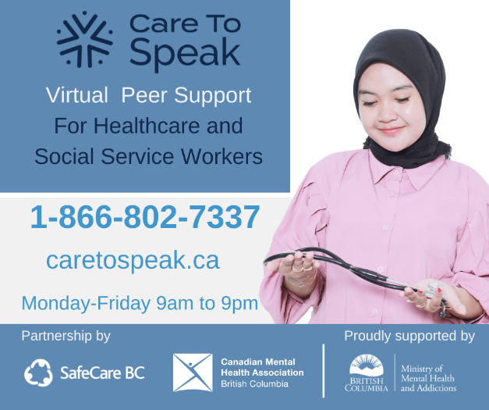 | As a healthcare and social service worker your mental health is a priority.  Care to Speak’s peer supporters understand the challenges you’re facing and are here to support you via phone call, text or chat Monday to Friday 9am – 9pm #caretospeak  https://bit.ly/37NJwDF  or to link to the media release  Tag: @cmha_bc  @safecarebc  @governmentofbc  @cmhavernon | As a healthcare and social service worker your mental health is a priority.  Care to Speak’s peer supporters understand the challenges you’re facing and are here to support you via phone call, text or chat Monday to Friday 9am – 9pm #caretospeak  #caretospeak #careforecaregivers #safecarebc #cmhabc #cmha #help  #mentalhealth #socialservices #healthcareheroes #careproviders #healthcareworkers #anxiety #depression #socialwork #mentalhealthresources #mentalhealthsupport #mentalhealthhelp #frontlineworkers #peersupport  Tag: @cmha_bc  @safecarebc  @governmentofbc  @cmhavernon  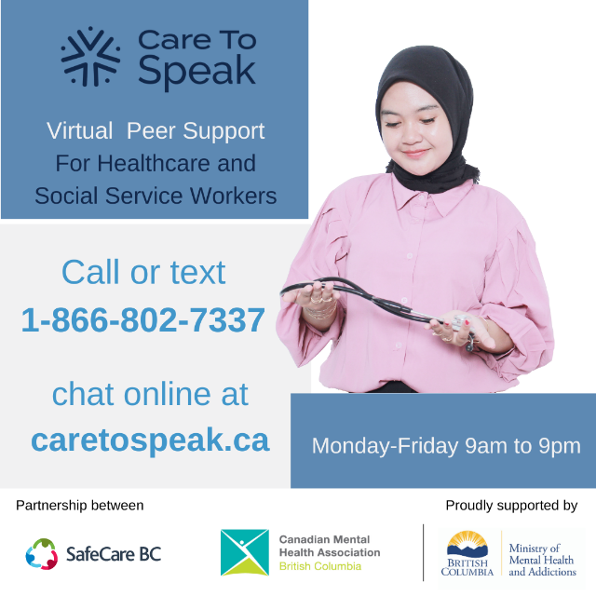
You always put others first, take time for yourself and reach out to Care to Speak.  Care to Speak’s peer supporters understand the challenges you’re facing and are here to support you Monday-Friday 9am-9pm via a phone call or text 1-866-802-7337 (PEER). Or an online chat at caretospeak.ca  #caretospeak  https://bit.ly/37NJwDF  or to link to the media release  Tag: @cmha_bc  @safecarebc  @governmentofbc  @cmhavernon  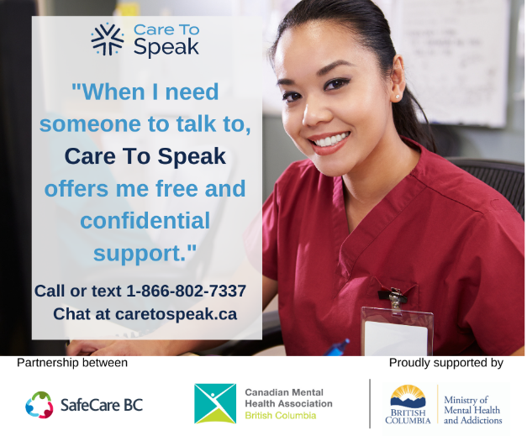 | You always put others first, take time for yourself and reach out to Care to Speak.  Care to Speak’s peer supporters understand the challenges you’re facing and are here to support you Monday-Friday 9am-9pm via a phone call or text 1-866-802-7337 (PEER). Or an online chat at caretospeak.ca  #caretospeak  https://bit.ly/37NJwDF  or to link to the media release  Tag: @cmha_bc  @safecarebc  @governmentofbc  @cmhavernon  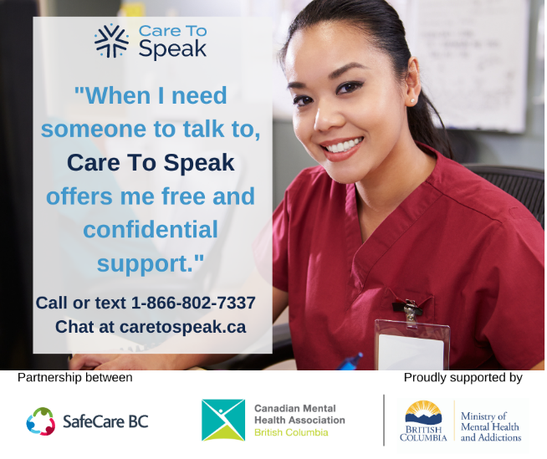 | You always put others first, take time for yourself and reach out to Care to Speak.  Care to Speak’s peer supporters understand the challenges you’re facing and are here to support you Monday-Friday 9am-9pm via a phone call or text 1-866-802-7337 (PEER). Or an online chat at caretospeak.ca  #caretospeak  #caretospeak #careforecaregivers #safecarebc #cmhabc #cmha #help  #mentalhealth #socialservices #healthcareheroes #careproviders #healthcareworkers #anxiety #depression #socialwork #mentalhealthresources #mentalhealthsupport #mentalhealthhelp #frontlineworkers #peersupport  Tag: @cmha_bc  @safecarebc  @governmentofbc  @cmhavernon
Worried about a friend or family member working in healthcare or social services?  Care to Speak is a confidential and free chat, text and telephone peer support service available Monday-Friday 9am-9pm. Send them the attached post and help them get the care they need #caretospeak  Tag:  @cmha_bc  @safecarebc  @governmentofbc  @cmhavernon  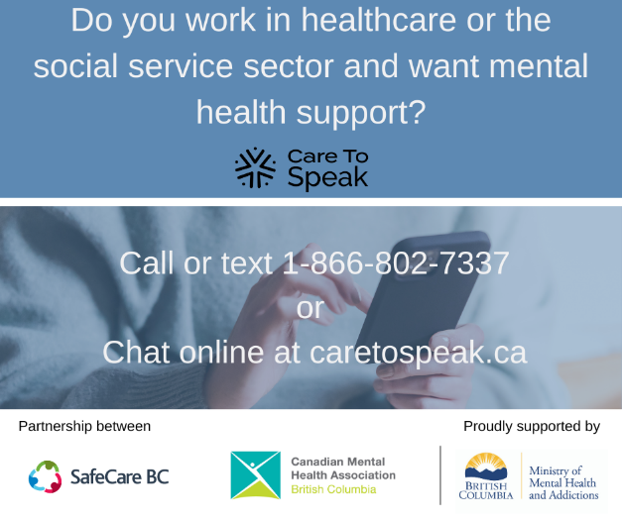 | Worried about a friend or family member working in healthcare or social services?  Care to Speak is a confidential and free chat, text and telephone peer support service available Monday-Friday 9am-9pm. Send them the attached post and help them get the care they need #caretospeak  Tag:  @cmha_bc  @safecarebc  @governmentofbc  @cmhavernon  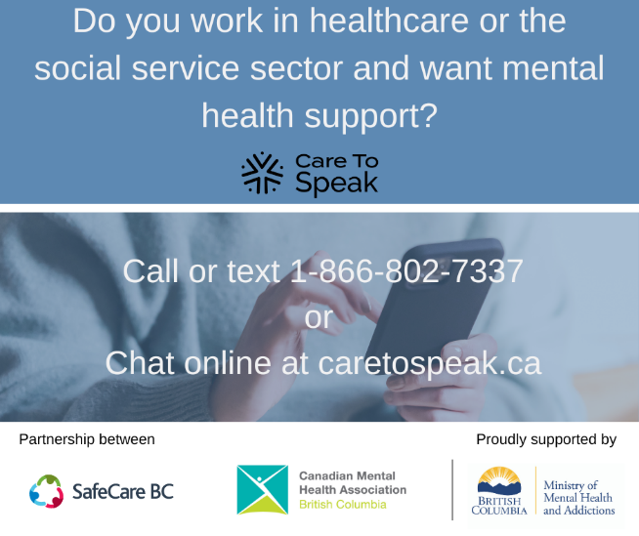 | Worried about a friend or family member working in healthcare or social services?  Care to Speak is a confidential and free chat, text and telephone peer support service available Monday-Friday 9am-9pm. Send them the attached post and help them get the care they need #caretospeak  #caretospeak #careforecaregivers #safecarebc #cmhabc #cmha #help  #mentalhealth #socialservices #healthcareheroes #careproviders #healthcareworkers #anxiety #depression #socialwork #mentalhealthresources #mentalhealthsupport #mentalhealthhelp #frontlineworkers #peersupport  Tag:  @cmha_bc  @safecarebc  @governmentofbc  @cmhavernon  